FOR IMMEDIATE RELEASE
PRESS RELEASE TITLE
Race Performance Manager: Physics-Driven Motorsport Simulation Announced on Steam
Turkey - June 9, 2026
INTRODUCTION
NeoN Studio has officially revealed its upcoming project, Race Performance Manager (RPM), now available to wishlist on Steam.
Moving away from traditional arcade-style management systems, Race Performance Manager delivers a deep motorsport simulation focused on the complete engineering cycle. Players are responsible for designing, developing, testing, and validating high-performance racing cars.
https://youtu.be/Fdp_cwNP16Y
Built around mathematical and engineering formulas rather than arbitrary stat modifiers, RPM challenges players to make meaningful technical decisions that directly influence performance, reliability, tire behavior, cooling efficiency, and race-day competitiveness.

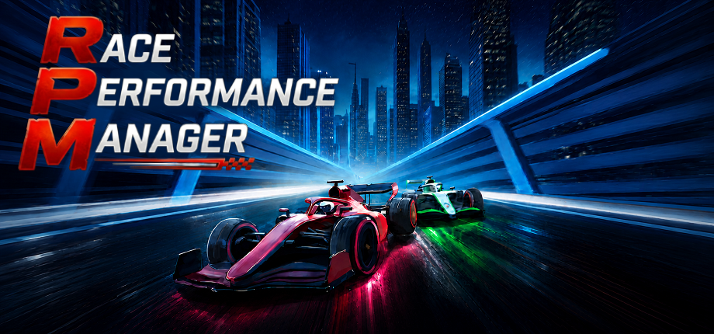

THE DETAILS
In Race Performance Manager, vehicle performance is driven entirely by engineering calculations. Engine output is generated from real RPM values, simulating the power delivered to the tires while accounting for drivetrain losses and ground interaction. Aerodynamic forces such as drag and downforce are calculated using real world formulas, with each component independently affecting the car's aerodynamic balance.
Environmental conditions also play an active role. Ambient temperatures influence cooling performance, while setup decisions impact how the car behaves throughout a race weekend.
The simulation extends beyond raw performance figures. Weight transfer, suspension behavior, tire loading, braking characteristics, and chassis balance are all calculated dynamically. Every setup adjustment has visible consequences on track, forcing players to balance outright speed with drivability, tire preservation, and reliability.
COMPONENT DEVELOPMENT, TESTING AND VALIDATION
Players take full control of 12 core vehicle components, each featuring 10 technological levels. Development follows a non-linear progression, meaning a highly optimized lower-level component may rival a poorly developed higher-level alternative.
To validate these upgrades, Race Performance Manager includes a comprehensive engineering workflow.
Players can:
• Analyze engine horsepower curves on dedicated test benches
• Adjust cam profiles to optimize power delivery across different RPM ranges
• Measure aerodynamic performance inside a wind tunnel environment
• Monitor cooling efficiency and thermal behavior
• Evaluate weight distribution and braking performance
• Test complete vehicle packages before race weekends
These represent only a portion of the available testing and validation activities throughout the engineering cycle.
Dedicated test drivers can be deployed to perform highly repeatable practice runs, allowing teams to gather reliable telemetry data and evaluate component wear under controlled conditions.
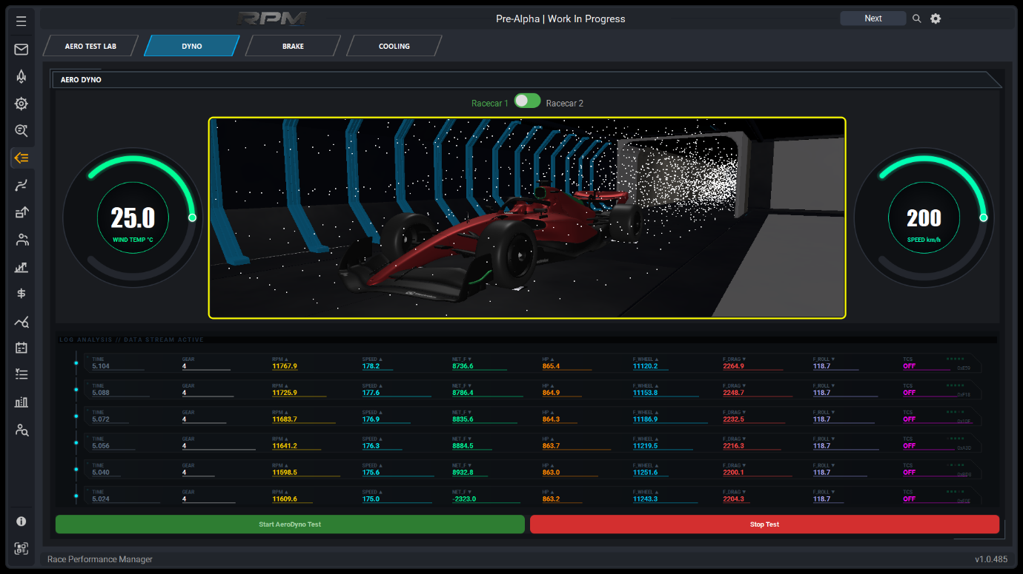
THE NEW CAR LAUNCH
Every development project ultimately feeds into one of the most important moments of the season: launching a new racing car.
As technology levels increase and engineering innovations accumulate, players must decide which solutions are mature enough to be incorporated into the next vehicle generation. Selecting the right combination of developments can dramatically improve competitiveness, while poor decisions may compromise the entire season before the first race even begins.
THE RACE WEEKEND
The championship consists of a complete 10-race season featuring a traditional race weekend structure.
Friday Practice sessions allow teams to refine setups and collect data.
Saturday Qualifying determines starting positions.
Sunday Race sessions put every engineering and strategic decision to the test.
Players can seamlessly switch between detailed 2D strategic views and immersive 3D race visualization with a single click.
Unlike many management games where AI competitors rely on simplified calculations, every one of the 20 cars on the grid is simulated using the same underlying physical model. The same systems used for the player’s vehicle are also applied to AI-controlled teams, creating a consistent and competitive simulation environment throughout the season.
Despite the complexity of the simulation, significant effort has been invested in optimization to ensure smooth real-time performance throughout race weekends, even while every car on the grid is being simulated simultaneously.

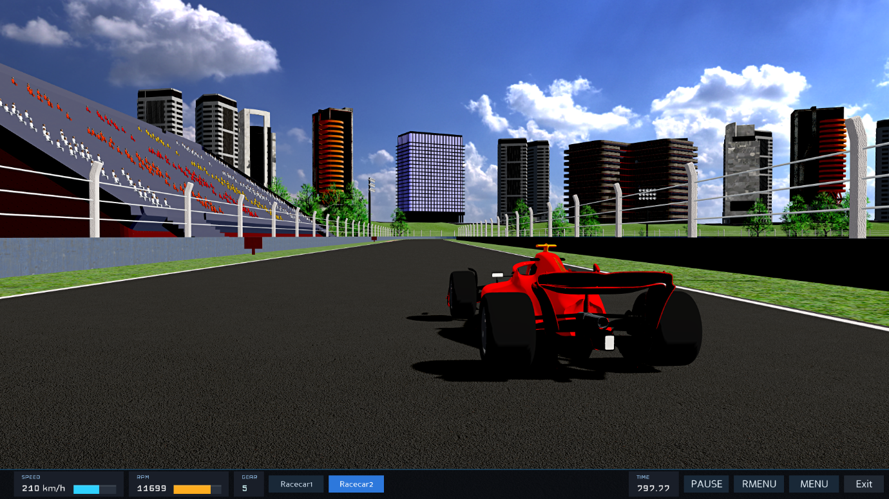
KEY FEATURES
• Math-Driven Physics: Engine power, aerodynamics, drivetrain losses, cooling systems, tire behavior, and numerous other vehicle dynamics are calculated using real-world formulas.
• Complete Engineering Workflow: Design, develop, test, validate, and launch new generations of racing cars.
• 12 Core Vehicle Components: Manage critical systems across 10 technology levels with extensive tuning opportunities.
• Advanced Wind Tunnel & Test Benches: Analyze aerodynamic performance, thermal limits, and mechanical behavior in dedicated testing facilities.
• Data-Driven Validation: Utilize test drivers and telemetry to evaluate upgrades before committing them to race weekends.
• The New Car Launch System: Combine your most successful engineering developments to create a new championship contender.
• Full Race Weekend Structure: Experience Practice, Qualifying, and Race sessions across a complete 10-race season.
• 2D / 3D Race Management: Switch instantly between strategic oversight and real-time race visualization.
• Equal Physics for All Competitors: Every AI-controlled vehicle operates under the same physical simulation as the player's team.
FACT SHEET Game Title:
Race Performance Manager (RPM)
Developer: NeoN Studio
Genre: Motorsport / Management / Simulation
Platforms: PC (Steam)
Game Modes: Single Player
Language Support: English
Release Date: TBA
Steam Store Page: https://store.steampowered.com/app/4315930/Race_Performance_Manager/

Media Assets & Press Kit Downloads:
• Raw Trailer MP4 Download
• High-Resolution Screenshots & Logos

OFFICIAL COMMUNITY & CHANNELS
Official Website: https://www.raceperformancemanager.com
Steam Page: https://store.steampowered.com/app/4315930/Race_Performance_Manager/
YouTube: https://www.youtube.com/@RacePerformanceManager
Reddit: https://www.reddit.com/r/RacePerformanceMgr/
WISHLIST NOW
Race Performance Manager is now available to wishlist on Steam. Players interested in realistic engineering-focused motorsport management can follow development progress and receive future updates through the official community channels.
ABOUT THE DEVELOPER
NeoN Studio is an independent game studio focused on creating engineering-driven management simulations that combine realistic systems with deep gameplay mechanics.
Founder & Lead Developer Email: info@raceperformancemanager.com

